

Republic of the Philippines
Department of Education
National Capital Region
DIVISION OF CITY SCHOOLS
Quezon City, Metro Manila

FIRST PERIODICAL TEST
MATHEMATICS II - SY 2012 - 2013

Name:_____________________ Yr & Section:_____________________
Date:___________________ Score:__________________

DIRECTIONS: Choose the letter corresponding to the correct answer. Write your answer before the number.

- Which polynomial has 2 terms?
A. 5xy B. 6x²y³z⁵ C. 4x² + 2y + 5 D. 2x³ + 7

2. What is the simplest form of ( 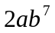) ( 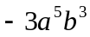) ?
A. 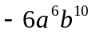 B. 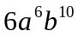 C. 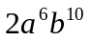 D. 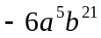

3. Which of the following defines a polynomial?
A. 2x⁻⁴ B. 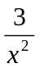 C. 3xy D. 
4. What must be added to 2x² – 5x + 4 to get 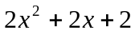 ?
A. 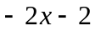 B. 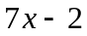 C. 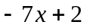 D. 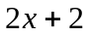

5. Write 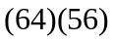 as product of the sum and the difference of two binomials.
A. ( 60 + 4 )( 60 – 4) B. ( 60 + 4)( 50 + 6) C. ( 50 + 14)( 60 – 4 ) D. ( 40 + 24)(40 + 16)

6. Apply special product rule to quickly find the product of ( 12m + 10 n)( 12m – 10 n).
A. 12m² – 10n² B. 144m² – 100n² C. 144m² + 100n² D. 12m² + 10n²

7. If x = 7 and y = 2, by how much is x² – y² greater than ( x − y)² ?
A. 10 B. 15 C. 20 D. 25

8. Evaluate 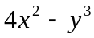 when 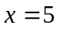 and 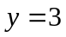.
A. 31 B. 40 C. 52 D. 73

9. Which of the following polynomial is a trinomial ?
A. 7xyz B. 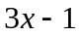 C. 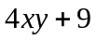z D. 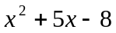

10. What is the common monomial factor of each term in the polynomial 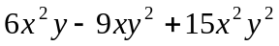?
A. 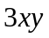 B. 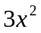 C. 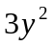 D. 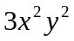

11. When a ≠ 0, how do you classify an equation in the form ax² + bx + c = 0 ?
A. linear B. quadratic C. cubic D. multinomial

12. The area of a rectangle is 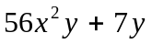. If its width is 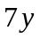, what is its length?
A. 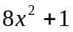 B. 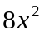 C. 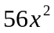 D. 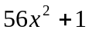

13. If ( 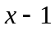) is a factor of the trinomial x² – 2x + 1, which one is another factor ?
A. (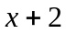) B. (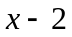) C. (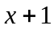) D. ( x – 1 )

14. For what value of k will give 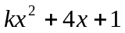 with 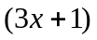 as one factor?
A. 1 B. 2 C. − 3 D. 3

15. If a * b = a ^{b} , what is 2 * 3 ? A. 5 B. 6 C. 8 D. 9

16. Which of the following is a perfect square trinomial?
A. 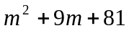 B. 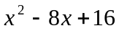 C. 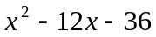 D. 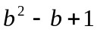

17. If the perimeter of a square is (4x – 8) cm, what is its area in sq cm?
A. x² + 4x + 4 B. x² − 4 C. x² − 4x + 4 D. x² + 4

18. Factor completely: 3x² – 27.
A. 3x + 9 B. 3x – 9 C. (x + 3) (x – 3) D. 3(x + 3)(x – 3)

19. Which of the following trinomials is not the square of a binomial?
A. 16x² + 8xy + y² C. 4x² + 4xy + y²
B. 9x² – 15xy + 25y² D. 9x² – 42xy + 49y²

20. What term should be added to x² + 40x + ____ to make it a perfect square trinomial?
A. 40 B.200 C.400 D.45

21. What is the product of ( 5x + 7 ) and ( 5x + 7 )?
A. 25x² + 12x + 49 C. 25x² + 70x + 49
B. 5x² + 24x + 49 D. 25x² − 70x + 49

22. Determine the nature of the roots of the quadratic equation 3x² – 4x + 1 = 0
A. two distinct rational roots C. two distinct irrational roots
B. two equal roots D. imaginary roots

23. When factored, what is the solution set of 3x² – 19x – 14 = 0?
A.{ , 7} B.{ – , – 7} C.{ – , 7} D. { , – 7}

24. What is the product of the roots of the equation 2x² – 3(x+6) = 0?
A. 18 B. – 18 C. 9 D. – 9

25. What number must be added to both sides of the equation x² + 8x = 4 so that the method of
completing the square can be used to solve its roots?
A. 4 B. 8 C. 16 D. 64

26. Find an equation with integral coefficients whose roots are – 3 and 5.
A. x² + 2x – 15 = 0 C. x² − 2x + 15 = 0
B. x² − 2x – 15 = 0 D. x² + 2x + 15 = 0

27. If b² – 4ac = 0, then what can be said about the roots of the given quadratic equation.
A. real, rational, equal C. real, irrational, unequal
B. real, rational, unequal D. imaginary

28. Raul can finish (x² + 5x + 6) pieces of barong in (x+2) hrs. What is her average rate per hour?
A. (x + 3) B. (x + 4) C. (x − 3) D. (x − 4)

29. The edge of a cube is (y +2)cm. What is its volume?
A. (y³ + 8) cm³ C. ( y³ + 6y² + 12y +8) cm³
B. (y + 6) cm³ D. (y³ + 5y² + 7y +6) cm³

30. A car travels at an average speed of (5x – 3) kph. How far in km will the car travel in (5x + 3) hours?
A. 25x − 9 B. 25x² − 9 C. 25x² + 30x − 9 D. 25x² + 9

31. What is the GCF of the expressions 24x²y³, 16x²y², and 32x³y²?
A. 4xy B. 8xy² C. 8x²y² D. 16 x²y²

32. Write the difference of squares 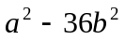as the product of two binomials.
A. ( a – b)( a – b ) B. ( a + 6b)(a – 6b) C. ( a + 6b)(a + 6b) D. ( a − 6b)(a − 6b)

33. Find the value of k for which the equation x² +10x + k = 0 has equal roots.
A.10 B. 25 C. 15 D. 50

34. In the equation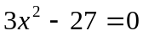, the use of extracting square roots will give what values of x ?
A. 3 B. −3 C. 3 D. 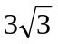

35. Which one is the quadratic equation whose roots are twice the roots of 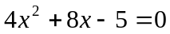?
A. 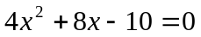 C. 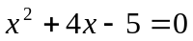
B. 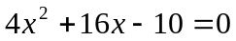 D.

36. If 3 is a root of the quadratic equation 3x² − 10x + k = 0, what is k?
A. 3 B. 4 C. 5 D. 6

37. Factor completely the expression x² – y² + x – y.
A. (x+ y)(x – y) C. (x + y)(x – y + 1)
B. (x – y)(x + y + 1) D. (x – y)(x – y + 1)

38. If the sum of the roots of x² + 6x +8 = 0 is added to the product of its roots, what is the result?
A. 14 B. 2 C. − 14 D. − 2

39. What is the product of 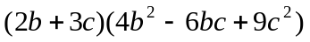?
A. 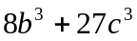 B. 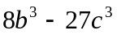 C. 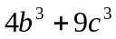 D. 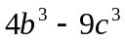

40. The product of two scores in a test is 48, and their sum is 14. What are the scores?
A. 2 and 24 B. 3 and 16 C. 4 and 12 D. 6 and 8

41. A rectangular garden has an area of 36sq m. If the width of the garden is 12 less than thrice
its length, what is its width?
A.3m B. 4m C. 6m D. 12m

42. What is the length in meters of the rectangular garden in number 41?
A. 3 B. 4 C. 6 D. 12

43. The side of a room is ( x – 3 ) cm. Its area is (x – 3 )² cm. Express the area as a perfect square trinomial.
A. 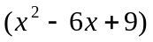sq cm C. 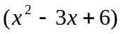sq cm
B. 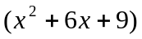 sq cm D. 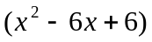sq cm
44. Find a quadratic equation whose roots are the reciprocals of the roots 3x² − 10x – 8 = 0.
A. 8x²+ 10x + 3 = 0 B. 8x² + 10x − 3 = 0 C. 8x² −10x −3 = 0 D. 8x²+ 10x + 3 = 0

45. Write an algebraic expression to represent the cost of (m + 2) articles at (m – 3) pesos per article.
A. m² – m + 6 B. m² + m+ 6 C. m² + m – 6 D. m² – m – 6

46. One side of a square is (a + b + 1)cm. Find its area.
A. (a² +b² +1 +2ab+2a+2b) cm² C. (a² +b² – 2 +2ab+2ab +3b) cm²
B. (a² +b² +1) cm² D. (a² – 2ab +2ab +b² +1 ) cm²

47. The area of a circle is (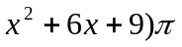sq m. How long in meters is its radius?
A. x – 3 B. x + 3 C. x + 6 D. x + 9

48. The sum of two numbers is 30. If their difference is 6, what are the numbers?
A. 18 & 12 B. 14 & 16 C. 10 & 20 D. 8 & 22

49. The perimeter of a rectangle is 32 m and its area is 63 sq m. What is the width of the rectangle?
A. 5 m B. 6 m C. 7 m D. 8 m

50. What is the length of the rectangle in problem number 49 ?
A. 6 m B. 7 m C. 8 m D. 9 m

- E N D −

/tvillaluna

Key – Mathematics II

- D
- A
- C
- B
- A
- B
- C
- D
- D
- A
- B
- A
- D
- D
- C
- B
- C
- D
- B
- C
- C
- A
- C
- D
- C
- B
- A
- A
- C
- B
- C
- B
- B
- C
- C
- A
- B
- B
- A
- D
- C
- C
- A

